**Travelling Salesman**

A salesman is selling products and is travelling from city to city along a set path. They make good profit but want to reduce the amount of gas that they use when driving from city to city. The goal is to visit as many cities as possible without visiting any city more than once. Do you think you can help solve the salesman’s problem? **Note:** You may start at any city but must end at another distinct city.

**Input:** The first line of input denotes **C**, the number of cities and **R**, the number of roads. The next **R** lines have two integers, which denote two cities which have a road that connect the two.

**Output:** The first line of output will be the distance of the shortest path taken to reach as many cities as possible without visiting one again. The second line will be the path taken in order. Keep in mind that there are many different paths, so it may not be exactly as the given output.

**Example Input:**

4 5

3 1

3 4

2 4

2 3

4 1

**Example Output:**

4

1 4 2 3

**Explanation:** In the given input, the map will look like this:

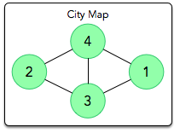

The given solution will appear as such:

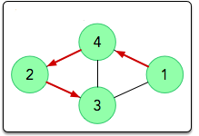

The distance is 4 since you visit all 4 cities without revisiting.